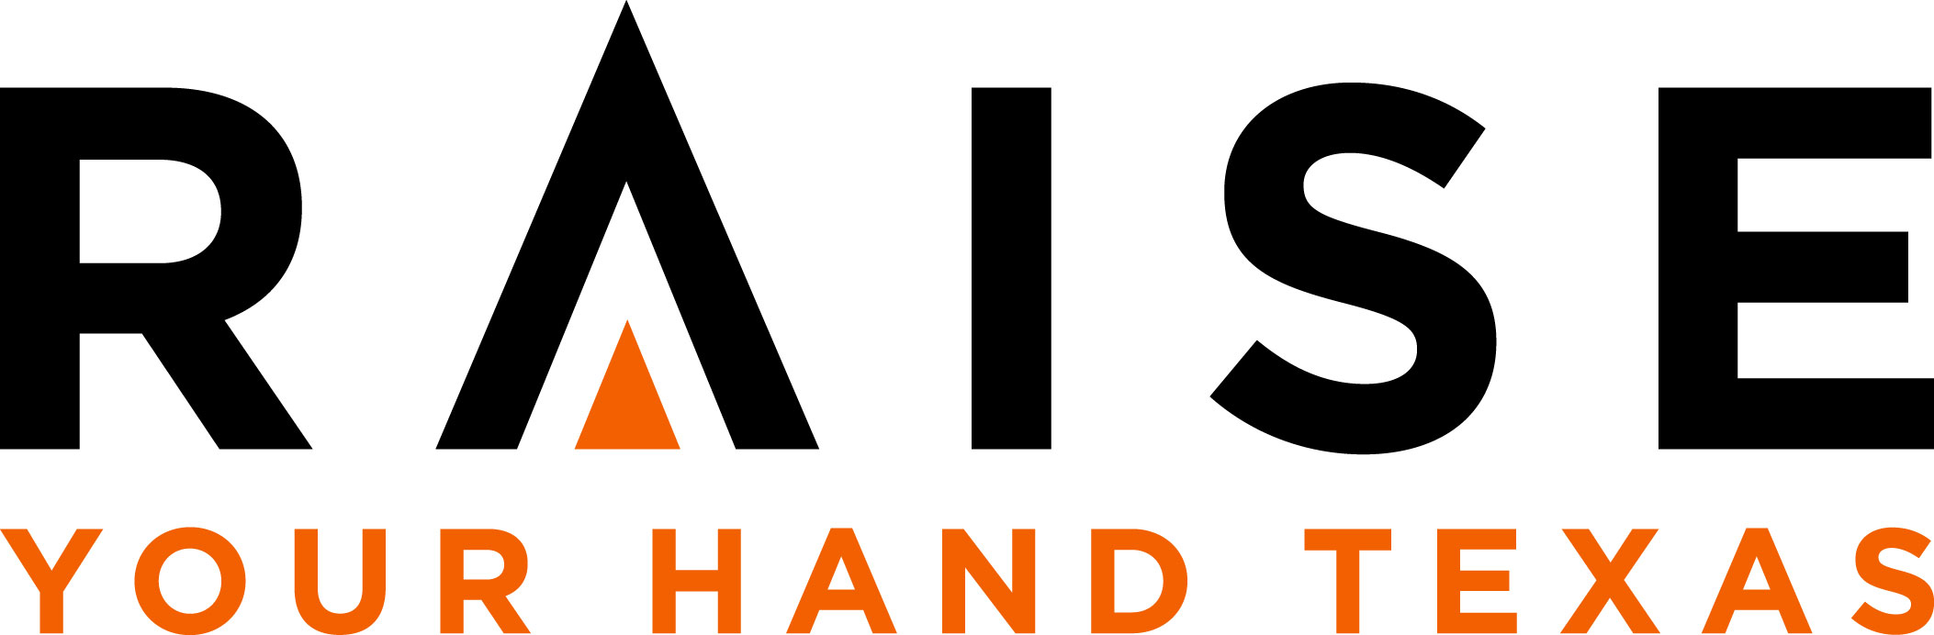

FOR IMMEDIATE RELEASE

CONTACT:
Petri Darby, VP of Marketing
pdarby@ryht.org or (512) 617-2137

(INSERT NAME) SPONSORED BY RAISE YOUR HAND TEXAS TO ATTEND HARVARD SUMMER INSTITUTES
- Raise Your Hand is sponsoring 110 school leaders statewide -

AUSTIN, TX (INSERT DATE) – Raise Your Hand Texas, a nonprofit working to strengthen and improve public education, is sponsoring 110 school leaders – including individual principals and school and district teams from 39 districts, and Education Service Center representatives – for summer leadership programs at The Principals’ Center at the Harvard Graduate School of Education. (INSERT NAME, TITLE, AND SCHOOL/DISTRICT AFFILIATION) is among those headed to Harvard this summer.

(INSERT QUOTE FROM INDIVIDUAL OR TEAM LEADER)

With this year’s group, Raise Your Hand Texas will have sponsored more than 1,000 school leaders to attend Harvard in the nine years of the program. This is the first year the organization opened sponsorship to teams.

“We know the Harvard program is transformational for many school leaders and we saw an opportunity to scale that impact by also sponsoring teams to attend,” said Cody Huie, director of leadership development for Raise Your Hand Texas. “This weeklong program serves as the launch pad for ongoing professional development, leadership and innovation events, and support through the Raise Your Hand alumni network.”

Raise Your Hand covers all expenses for those selected, including program tuition fees, travel, hotel and other discretionary funding – an average of about $9,200 per attendee, for a total of more than $1 million in sponsorships for 2017, and more than $8 million since the program’s inception.

Attendees will join education leaders from around the globe in one of the following six institutes, and engage in training and workshops led by international education and leadership experts.

- National Institute for Urban School Leaders
- Improving Schools: The Art of Leadership
- Leadership: An Evolving Vision
- Closing the Achievement Gap
- Family Engagement in Education
- School Turnaround Leaders

Each Institute lasts for 5-7 days, between June 5 and July 27, 2017.

# # #

About Raise Your Hand Texas
Raise Your Hand Texas is a non-profit, non-partisan organization that identifies and pilots promising ideas to improve public education, and supports the conditions and public policies needed to scale proven approaches to benefit all Texas students. Visit RaiseYourHandTexas.org to learn more.

Twitter: @RYHTexas
Facebook: /RaiseYourHandTexas
Instagram: /RaiseYourHandTexas

(INSERT SCHOOL/DISTRICT INFORMATION IF APPLICABLE)

